The AS Canvas Course is now ready to allow students to complete the required training in order to gain access to the Microix system as requestors.

When you access the Canvas Course, click on “Modules” in the left navigation bar to get started through the Canvas Course. As you complete each module, new ones will unlock. Once you’ve fully completed the “Microix Requestor” module, you will be considered eligible to gain access to Microix. No further action is needed on your part as your completion status will automatically periodically sync with Microix. We know that you are all anticipating gaining access to Microix. Once you complete this training, and your status is updated in Microix, you will receive a separate invitation email to join and access to Microix. Should you not receive your welcome email to Microix within 2 weeks, please contact the AS FinOp Team for assistance.

We are still working hard on developing the workflow for the new Authorized Signers process. We anticipate this to be completed within the next few weeks and will have a followup email to announce and explain the process.

Of course, we are always looking for your feedback. If you have any feedback to give for the new AS Canvas Authorized Signer Training or for MIP/Microix in general, please let us know as we continue to make improvements.

Some of you are already a part of the Canvas Course from AS ONE. If you need access to the Canvas Course you can:

- Click here
- Copy and paste this link into your browser: https://ucsb.instructure.com/enroll/N4AJGE
- Scan the QR code:
  - 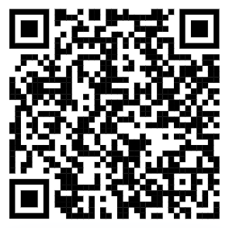
In the future, we hope to have this Canvas Course be your one-stop-shop for quick reference resources, Microix access, Authorized Signer Training, and General AS Training. For now, as we continue to work on and build out the Canvas Course, it currently contains a few quick reference resources. President Metzger will dive deeper into the future of this Canvas page and General AS Training at a later date.

